EXP: 1
Date : 08-07-2026

DDL Commands – CREATE, ALTER, DROP
AIM:
To Create, Alter, Drop, Rename, Truncate using Data Definition Language (DDL) statements.

Description:
Data Definition Language (DDL) statements are used to define the database structure or schema.
DDL Commands: Create, Alter, Drop, Rename, Truncate

PROCEDURE :
Step 1: Create a new database for storing movie details.
Step 2: Select the created database to perform the required operations.
Step 3: Create a table named Movies with the attributes M_id, Movie_Name, Male_Lead, Female_Lead, Director, and Music.
Step 4: Verify the structure of the created table.
Step 5: Insert the movie details into the Movies table.
Step 6: Display all the records in the Movies table to verify that the data has been inserted successfully.
Step 7: Alter the Movies table by adding a new attribute named Ott.
Step 8: Modify the data type/size of the Ott attribute as required.
Step G: Rename the Movies table to Movie_Details.
Step 10: Verify that the table has been renamed successfully.
Step 11: Truncate the Movie_Details table to remove all records while retaining the table structure.
Step 12: Verify that all records have been deleted from the table.
Step 13: Drop the Movie_Details table from the database.
Step 14: Verify that the table has been removed successfully from the database.

Query 1:
CREATE TABLE movies ( M_id INT,movies_name VARCHAR(50),Male_Lead VARCHAR(50),Female_lead VARCHAR(50),Director VARCHAR(50),Music VARCHAR(50));

Output 1 :

Query 2:
INSERT INTO Movies VALUES (101, 'Dude', 'Pradeep Ranganathan', 'Mamitha', 'Keerthiswaran', 'Abhyankar');

Output 2 :

ALTER TABLE movies Add Ott VARCHAR(15) ;
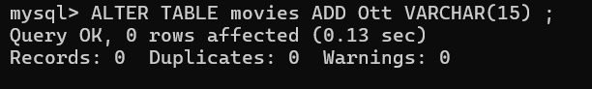

Query 3 :
INSERT INTO movies (M_id, movies_name, Male_Lead, Female_lead, Director, Music)values(103, 'OG', 'Pawan Kalyan', 'Priyanka Mohan', 'Sujeeth', 'S S Thaman'), (102, 'Premalu', 'Naslen', 'Mamitha', 'Girish A D', 'Vishnu Vijay'),
(104, 'Petta', 'Rajnikanth', 'Simran', 'Karthik Subbaraj', 'Anirudh');

OUTPUT 3 :
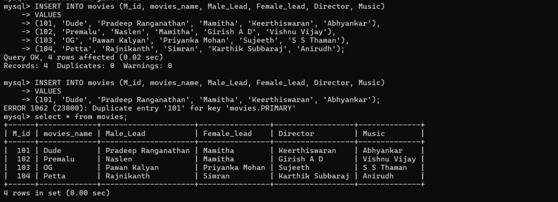

Query 4 :
Desc movies;

OUTPUT 4 :
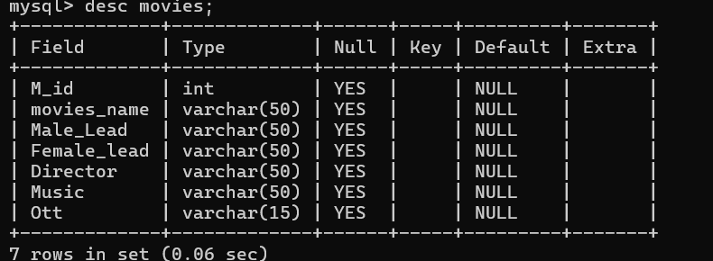

Query 5 :
Truncate table movies;

OUTPUT 5 :
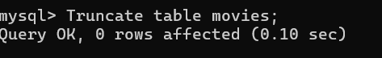

Query 6 :
Drop Table movies;

OUTPUT 6 :
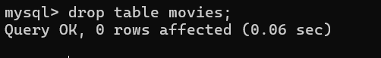

Result : Tables are created, altered and modified using DDL commands.

